Assignment -1: Parameter Edition
By Peter Schönung, Taha Sekerci, Kavya Valluru

Introduction:
In chemical reaction engineering, parameter estimation is the core function which is used to determine the reaction kinetics from the experimental data when they are not fully known. This report concentrates on the batch reactor system involving (Ab, B, C and D) using concentration and time data. The objective is to propose plausibility, formulate rate reactions, conclude reaction networks and estimate kinetic parameters. These kinetic parameters are important for the reaction networks as they quantify reaction rates and describe their dynamic behavior [1] and varying them tells how strong the reaction network changes in mechanism, uncertainty, and operating conditions. [2]In this assignment, a reaction network model is established and reaction rate constants are fitted to a set of concentration profiles and limfit.minimizer is used to find the parameters.

Results and Discussion:
The results of the study for the experiments 0-5 are discussed below,

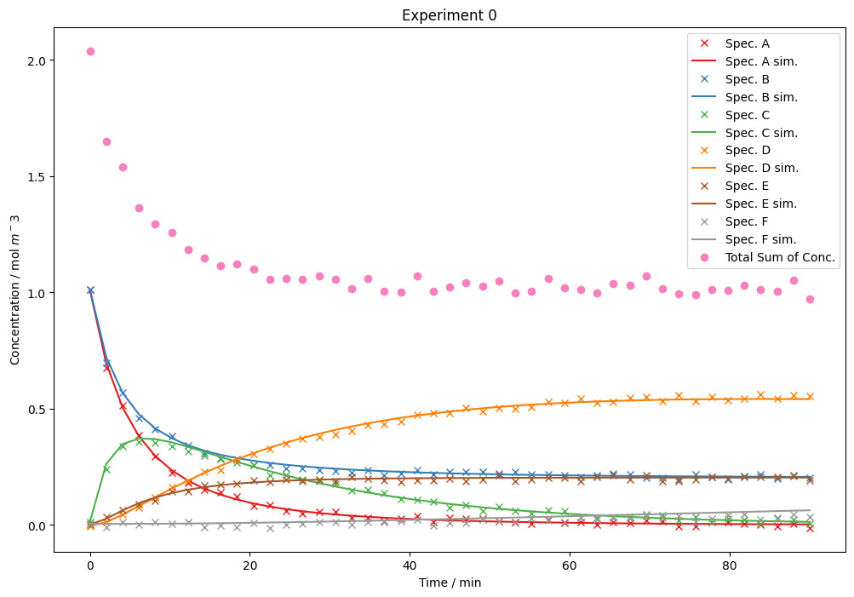

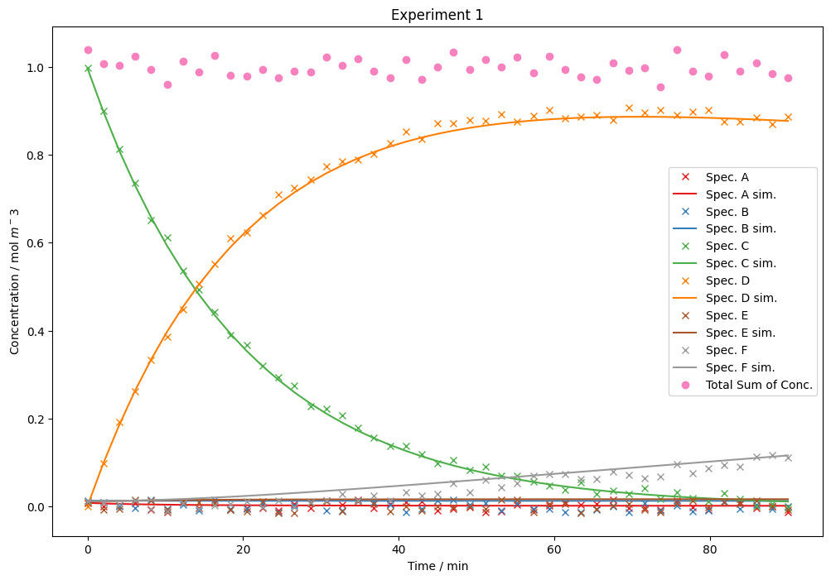

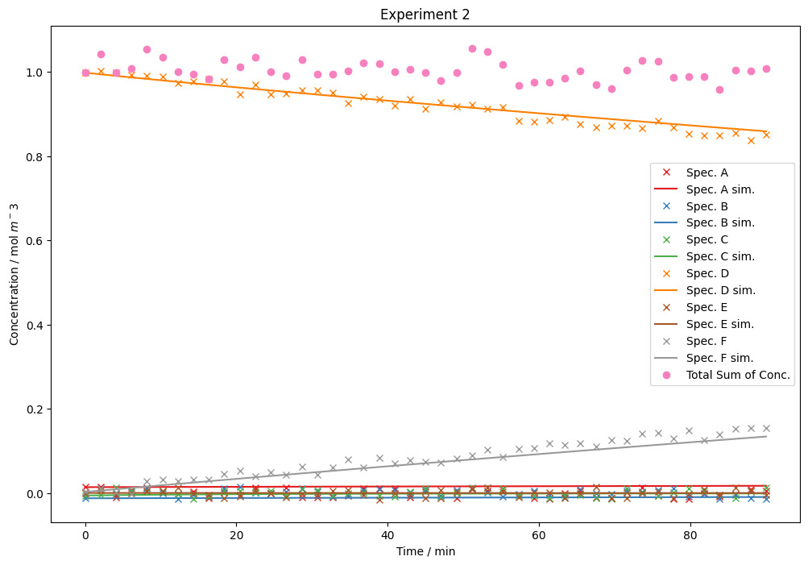

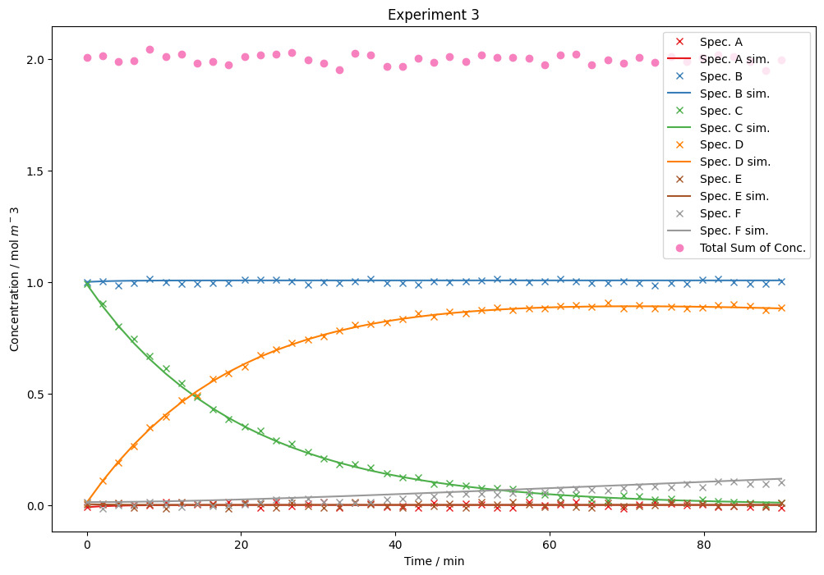
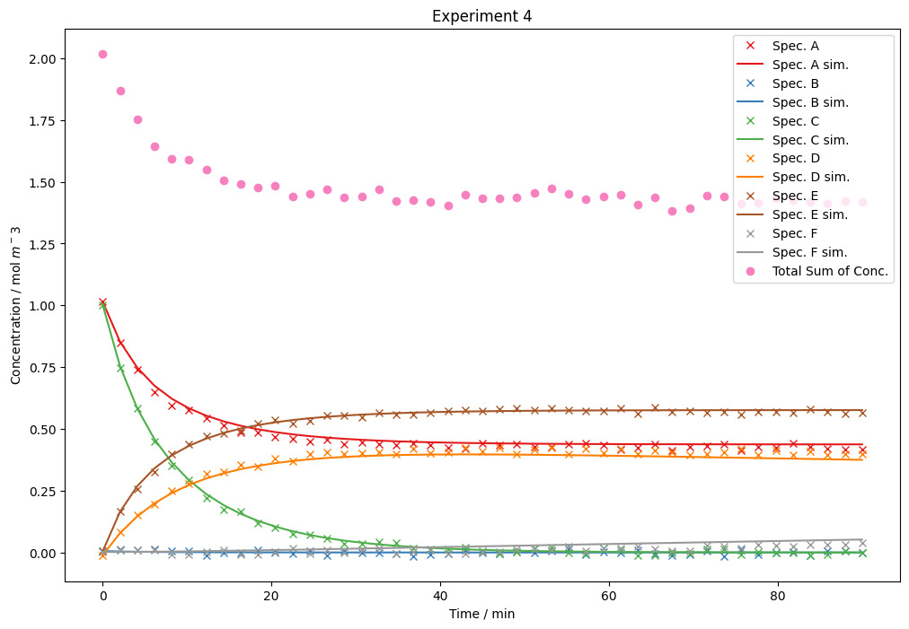

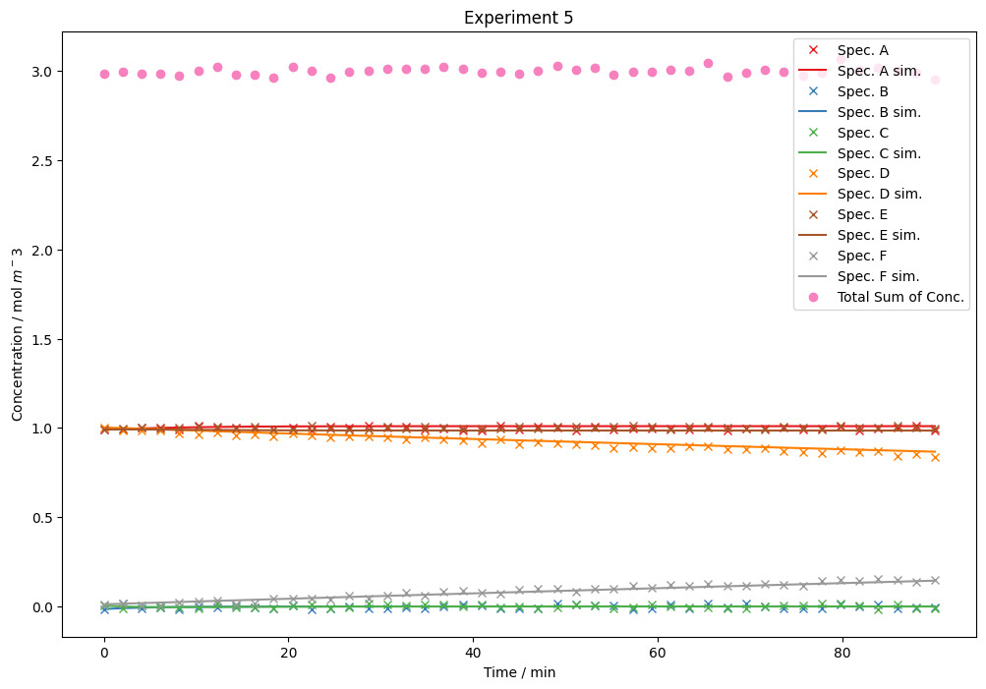
The concentration and time graphs for experiments 0-5 shows how the concentrations of different species change A-F changes during the reaction.
At the beginning, the changes are faster cause the concentration of the reactants is high, leading to higher reaction rate. As time progresses the reactants are consumed so the rate of reaction lowers and change in concentration becomes slow. This behavior agrees with rate law theory, where reaction rate depends on reactant concentration. Experimental data is compared with simulated values and they showed good correlation.

Conclusion:
The experimental data from the six experiments were analysed and plotted and got the four reaction networks involving A to F. Parameter estimation was performed using limfit.minimizer and yielded the values of rate constants
(k₁ = 0.1975, k₀ = 0.0960, k₂ = 0.0503, k₃ = 0.00158 m³ mol⁻¹).
For checking the average mathematical error, co-efficient of determination R² is used and the values of R² are above 95% which produced optimum results.
An average RMSE deviates by 0.0121 mol m⁻³.
The results of the parameter estimation and model evaluation confirms that the reaction network provides accurate kinetics.
Further work could look into how temperature affects the reaction by determining the energy, as well as this would help in finding the most influenced reactions and guide any further optimization of the process.
References
[1] Parameter Estimation for Kinetic Models of Chemical Reaction Networks from Partial Experimental Data of Species´Concentrations
https://pmc.ncbi.nlm.nih.gov/articles/PMC10526083/
[2] Model-based evaluation and data requirements for parallel kinetic experimentation and data-
driven reaction identification and optimization
https://pubs.rsc.org/en/content/articlehtml/2023/dd/d3dd00016h
[3] The change of concentration with time
https://chem.libretexts.org/

